An AI for Non-Coders:
Vercel AI
by Aman Abdullah

Introduction: Building Without Knowing How to Code
For a long time, building an app or website felt like something reserved for programmers. You needed to know HTML, CSS, JavaScript, frameworks, hosting, databases, deployment, debugging, and a dozen other technical terms before you could even publish something simple. With the introduction of Artificial Intelligence and various tools, the barrier is much lower now.
Vercel’s AI tool, known as v0, is part of a new generation of AI tools that can turn plain-language prompts into working websites and applications. Instead of starting with a blank code editor, users can begin with an idea:
“Create a landing page for a small bakery with a menu section, customer reviews, and a contact form.”
With just this prompt, v0 can generate the visual layout, website UI, and a working front-end code. From there, the user can revise the result through conversation, like giving feedback to a designer or developer.
Vercel describes v0 as an AI agent that helps people create real code, full-stack apps, agents, live prototypes, and production-ready projects using prompts. It can also help users refine designs, update copy, and deploy projects through Vercel’s platform.
This makes it very useful for non-coders, including entrepreneurs, students, designers, marketers, teachers, small business owners, and anyone who has an app idea but does not know where to begin with coding
In this chapter, we will explore what Vercel AI is, how it works, how beginners can prompt it effectively, and how to evaluate its outputs critically.

What is Vercel AI?
Vercel is a company known for helping developers build, deploy, and scale web applications. It also offers AI-focused tools, including the Vercel AI SDK for developers and v0, an AI-powered app and website builder. For the purpose of this chapter, we will focus mainly on v0 by Vercel, because it is the tool most relevant for non-coders.

Vercel’s v0 allows users to generate apps and websites using everyday language. You describe what you want, and the AI puts out a working interface or application. Vercel’s own website summarizes the process as: “Prompt. Build. Publish.” According to them, users can generate working applications in minutes and publish them as live websites in seconds.
This is different from a chatbot that only gives advice. Vercel AI does not merely explain how to build a website. It can generate the code and design completely, just from the user’s description.
For example, a user could ask it to create:
“A modern portfolio website for a photographer with a homepage, gallery page, booking form, and pricing section.”
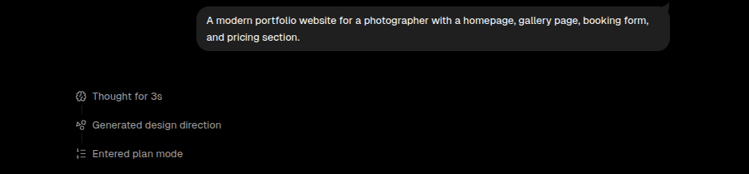
v0 will then make an implementation plan along with all the details for the user to review.
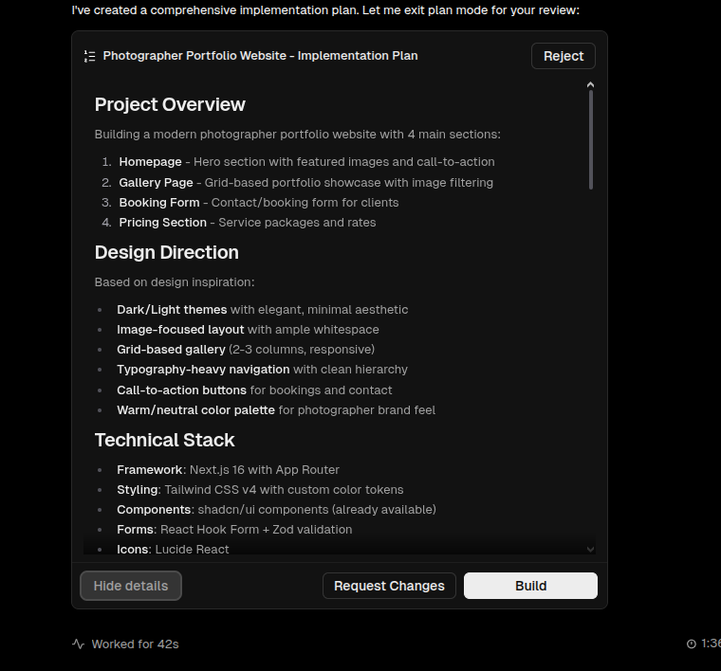

The user can then either see the details, accept or make changes to this plan.
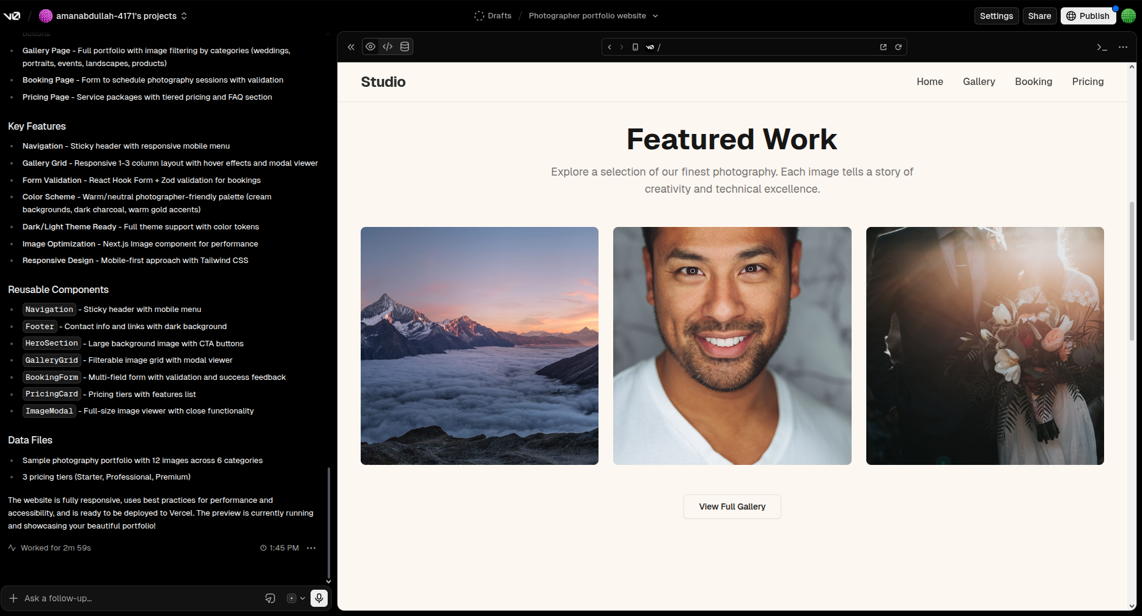
As you can see, from just that single line of prompt, v0 created a whole website. We can then make follow-up changes like telling it to implement ‘Dark Mode’ to the site etc.
How Vercel AI Works at a Basic Level
A beginner does not need to understand every technical detail behind Vercel AI, but it helps to know the basic workflow.
The process usually looks like this:
- The user enters a prompt describing an app, website, page, or component.
- Vercel AI generates a design and code-based result.
- The user previews the output.
- The user gives follow-up instructions to improve it.
- The project can be published, exported, connected to a repository, or developed further.
Vercel’s current v0 platform includes features such as templates, visual editing, GitHub syncing, app integrations, and one-click deployment to Vercel.
The most beginner-friendly part is that the user can stay in plain language. Instead of saying:
“Create a responsive React component using Tailwind CSS with a grid layout and form validation,”
A beginner could say:
“Create a clean contact page that works well on phones and includes fields for name, email, message, and a submit button.”
The AI handles the technical translation.

Prompting Vercel AI Effectively
Good results depend on good instructions. A vague prompt can produce a vague website. A clear prompt gives the AI more to work with.
A weak prompt might be:
“Make me a business website.”
This is too broad. What kind of business? What pages are needed? What style should it have? Who is the audience?
A stronger prompt would be:
“Create a professional website for a home cleaning service in Dhaka. Include a homepage, service packages, customer reviews, booking form, FAQ section, and contact information. The design should feel trustworthy, simple, and friendly. Use clear call-to-action buttons like ‘Book a Cleaning’ and ‘Get a Free Quote.’”
This prompt is better because it includes the purpose, audience, sections, tone, and design direction.
A useful prompt for Vercel AI often includes six parts:
1. The project type
Say whether you want a landing page, dashboard, portfolio, mobile-style app, booking system, blog, marketplace, calculator, or something else.
2. The audience
Mention who will use it. A website for children should look different from a dashboard for accountants.
3. The main features
List the sections, pages, buttons, forms, or tools you need.
4. The style
Describe the look and feel. Use words like clean, playful, luxury, minimal, colorful, corporate, futuristic, academic, or friendly.
5. The content
Provide names, sample text, pricing, product details, or project descriptions where possible.
6. The constraints
Mention anything important, such as mobile-friendly design, simple navigation, accessibility, or no login required.
A reusable prompt template could look like this:
“Build a [type of website/app] for [target audience]. The purpose is to [main goal]. Include [list of sections or features]. The design should feel [style words]. Use [brand colors or tone, if any]. Make it easy to use on mobile. Add realistic sample content.”
For example:
“Build a landing page for a beginner-friendly online English course for university students. The purpose is to encourage students to sign up for a free trial class. Include a hero section, course benefits, instructor bio, pricing plans, student testimonials, FAQ, and signup form. The design should feel modern, welcoming, and trustworthy. Use realistic sample content and make it mobile-friendly.”

Iteration: The Real Secret
Many beginners expect AI to produce the perfect result immediately. That is rarely how it works.
A better way to think about Vercel AI is as a fast creative partner. It gives you a first draft, then you improve it through feedback.
Useful follow-up prompts include:
Make the homepage more visually appealing.
Simplify the language for a general audience.
Add more spacing between sections.
Make the design more premium.
Change the layout so the pricing section appears before testimonials.
Make the call-to-action buttons more noticeable.
Add a dashboard page with charts and summary cards.
Rewrite the copy to sound warmer and less corporate.
Make the website suitable for mobile users first.
This process is similar to working with a human designer. You would not simply say “make a website” and expect perfection. You would review drafts, give feedback, and refine the result. Vercel AI makes this cycle much faster.

What Vercel AI Is Good At
Vercel AI is especially strong for turning ideas into visible prototypes. It is useful when the goal is to create something quickly, test an idea, or communicate a concept to others.
It is good for:
Landing pages
A startup, event, product, service, or personal brand can quickly get a polished web page.
Portfolios
Students, designers, writers, developers, and freelancers can create personal websites.
Dashboards
Vercel AI can create admin panels, analytics pages, finance dashboards, project management screens, and other data-style interfaces.
App prototypes
If someone has an idea for a fitness tracker, study planner, budget app, or recipe organizer, they can generate a visual prototype.
Client mockups
Freelancers can quickly show clients what a future website might look like.
Learning by example
Even non-coders can inspect the generated structure and begin to understand how modern websites are organized.
Design exploration
Users can ask for multiple versions of the same idea, such as minimal, colorful, luxury, playful, or corporate.
This is why Vercel AI is valuable not only as a building tool but also as a thinking tool. Seeing an idea on screen helps users make decisions.

What Vercel AI Is Not Good At
Although Vercel AI is powerful, it has limits. Beginners should understand these limits clearly.
First, the generated project may not always be fully ready for real-world use. A prototype can look complete while still missing important backend logic, security checks, database connections, payment handling, or error handling.
Second, AI-generated code may contain mistakes. It may produce broken features, confusing structure, or unrealistic sample data. The user should test everything carefully.
Third, visual quality can vary. Sometimes the first design looks generic. It may need several rounds of prompting before it feels polished.
Fourth, Vercel AI does not replace product thinking. The user still needs to know the purpose of the app, who it is for, and what problem it solves.
Fifth, non-coders may still need help for advanced deployment, custom domains, databases, authentication, payment systems, privacy policies, or legal compliance.
The most responsible way to use Vercel AI is to treat it as a rapid builder and assistant, not as an expert.

Evaluation: How to Judge the Output
Because this book is about prompting, evaluation, and critical comparison, it is important to ask: how do we know whether the AI’s result is good?
A beginner can evaluate a Vercel AI output using five simple questions.

1. Does it match the original goal?
If you asked for a booking website, does it clearly help users book something? If you asked for a portfolio, does it highlight your work?
A beautiful design is not enough. The website must serve its purpose.

2. Is it easy to understand?
A visitor should know what the website is about within a few seconds. The headings, buttons, and layout should guide the user naturally.
If the page feels confusing, ask Vercel AI to simplify it.

3. Does it work on mobile?
Many users will visit websites from phones. Always check whether the design looks good on smaller screens.
A useful follow-up prompt is:
Improve the mobile layout. Make the buttons easy to tap, reduce clutter, and make the sections stack cleanly.

4. Is the content specific or generic?
AI often uses vague phrases like “transform your workflow” or “unlock your potential.” These may sound polished but do not say much.
Ask for concrete language:
Rewrite the homepage copy to be more specific. Avoid generic marketing phrases. Mention the actual service, benefits, and audience.

5. Are there any missing real-world requirements?
A real website may need privacy information, contact details, accessibility, loading states, error messages, working forms, database connections, or security protections.
For serious use, the AI output should be reviewed by someone with technical experience.

Critical Comparison: Vercel AI vs. Other AI Tools
Vercel AI is not the only tool that can help non-coders. Other tools, such as ChatGPT, Claude, Canva, Framer, Webflow, Wix, Durable, and Bubble, can also help with websites, code, or prototypes.
The difference is that Vercel’s v0 is strongly connected to modern web development. It is designed to generate real interface code and support deployment through Vercel. Vercel states that v0 can help users deploy to production, open pull requests, and create live prototypes with prompts.
Compared with a general chatbot, Vercel AI is more directly focused on building web interfaces and apps.
Compared with traditional website builders, it can feel more flexible because users can describe custom layouts and features instead of only choosing from fixed templates.
Compared with professional development, it is faster and more accessible, but less reliable for complex or high-risk applications unless reviewed by developers.
A fair comparison might look like this:
ChatGPT is excellent for brainstorming, writing copy, explaining code, and planning features.
Canva is excellent for visual design, presentations, and simple web pages.
Wix and Webflow are useful for website building with visual controls.
Bubble is useful for no-code web applications with workflows and databases.
Vercel AI is especially useful for generating modern web app interfaces, prototypes, and deployable projects from prompts.
The best tool depends on the user’s goal. For a simple flyer-style website, Canva or Wix may be easier. For a startup prototype or web app interface, Vercel AI may be more powerful.

A Beginner-Friendly Workflow
For non-coders, the best way to use Vercel AI is not to start with a huge project. Start small.
A simple workflow could be:

Step 1: Define the goal
Write one sentence:
I want to create a website that helps people book appointments for my tutoring service.

Step 2: List the needed sections
For example:
Homepage
Services
Pricing
About
Testimonials
Booking form
Contact

Step 3: Write the first prompt
Combine the goal and sections into a clear instruction.

Step 4: Review the first version
Look at the layout, text, buttons, and flow. Do not worry if it is imperfect.

Step 5: Give focused feedback
Ask for one improvement at a time:
Make the design more friendly.
Add a pricing comparison table.
Improve the mobile version.
Rewrite the text for parents of school students.

Step 6: Test the result
Click buttons. Check forms. Look at mobile view. Read all text carefully.

Step 7: Ask for final polish
Use prompts like:
Review this website for clarity, usability, and trust. Improve anything that feels confusing or generic.

Step 8: Get technical review if needed
For public, business, or customer-facing projects, ask a developer or technical person to review before relying on it fully.

Pricing
Vercel offers a free version and 3 paid packages. A free account gets $5 monthly credits and it is sufficient for building drafts to see if you want to upgrade to a paid account.
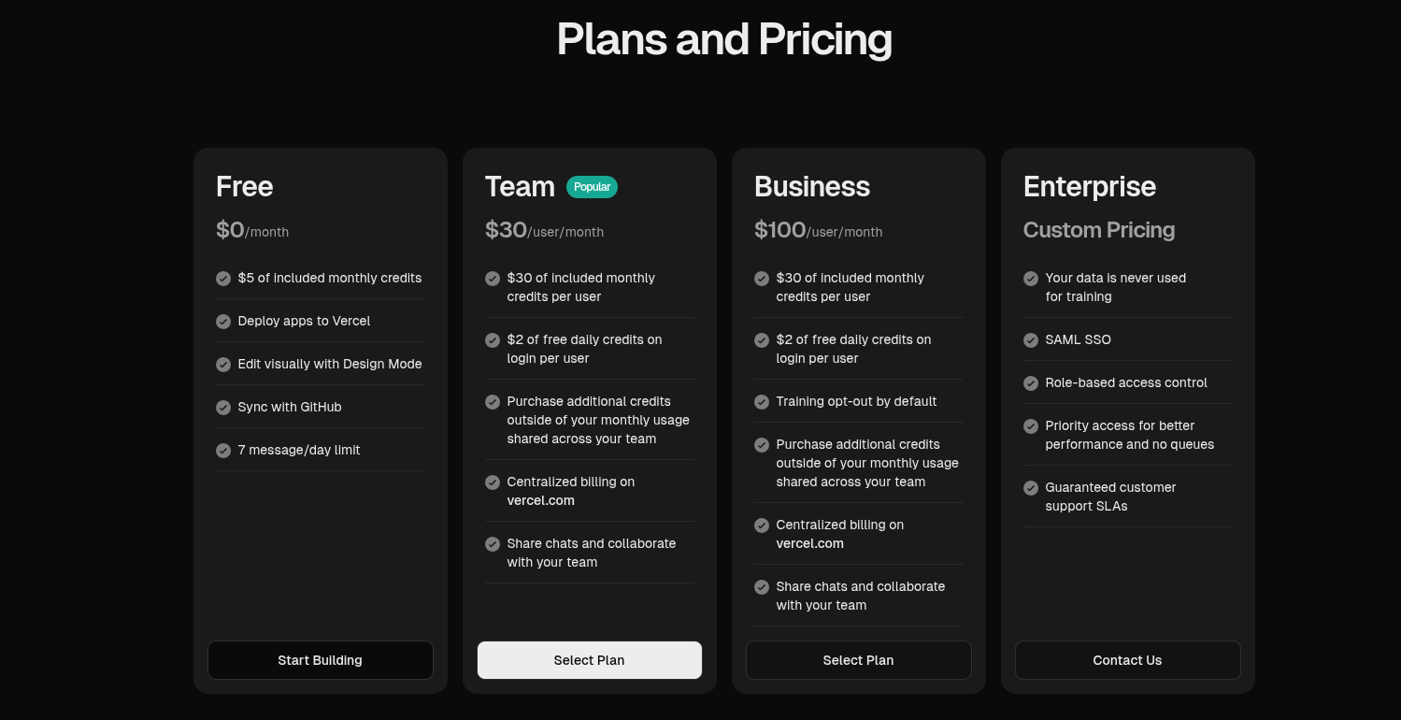

Final Thoughts: From Idea to Prototype
Vercel AI represents a major change in how people build for the web. It gives non-coders a way to participate in digital creation without waiting for permission, funding, or technical training.
A person with an idea can now create a prototype in minutes. A student can build a portfolio. A business owner can test a landing page. A founder can show investors a product concept. A teacher can design a classroom tool.
This does not remove the need for developers. Instead, it changes where the starting line is. Non-coders can now arrive at the conversation with something visible, clickable, and testable.
That is the real value of Vercel AI. It does not simply write code. It helps people think through ideas by making them real enough to see, use, and improve.
For beginners, the most important skill is not coding. It is clear communication. The better you can explain what you want, who it is for, and how it should work, the better the AI can help you build it.
In that sense, Vercel AI is more than an app builder. It is a bridge between imagination and implementation.

Contribution:
Name: Aman Abdullah
ID: 2231445630
AI Tool used:
ChatGPT Plus
GPT Tool: Write for me

